**A Walk Through of How I Built This Dashboard**

1. Open Power BI desktop and click on “New” to generate a new workbook.
2. Click on import data from excel tab, navigate through to locate the file you want to download and then click open.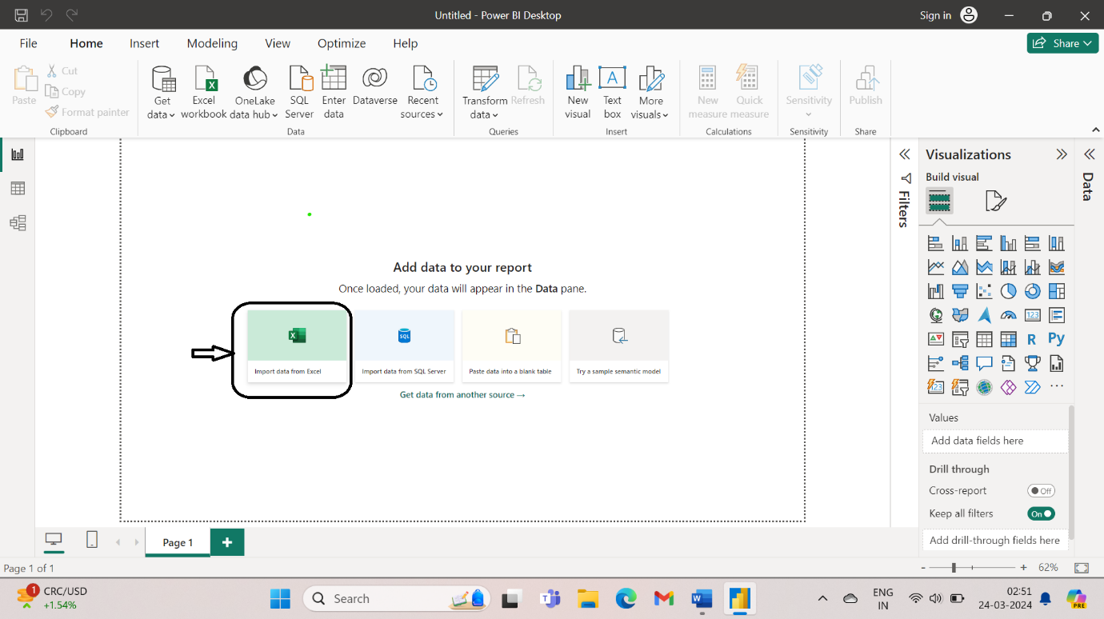

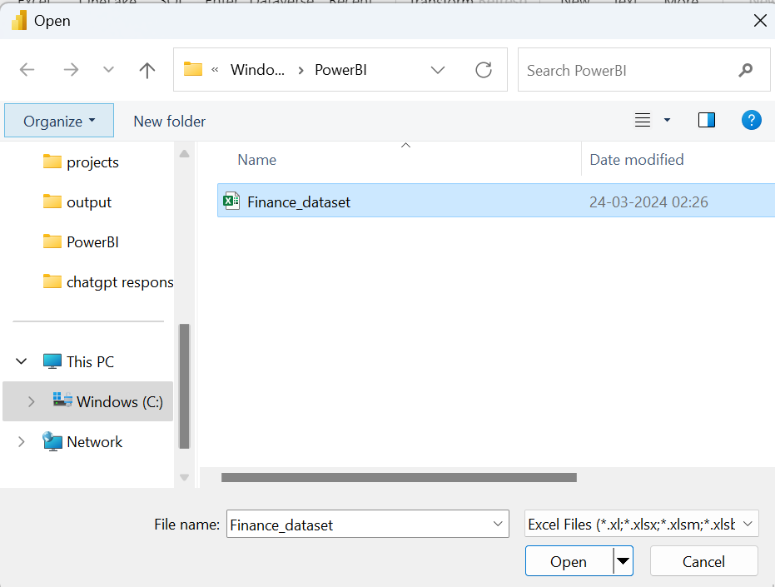

1. Select Sheet1 from “Navigator” and then click on load button. This loads the dataset onto the Power BI desktop.

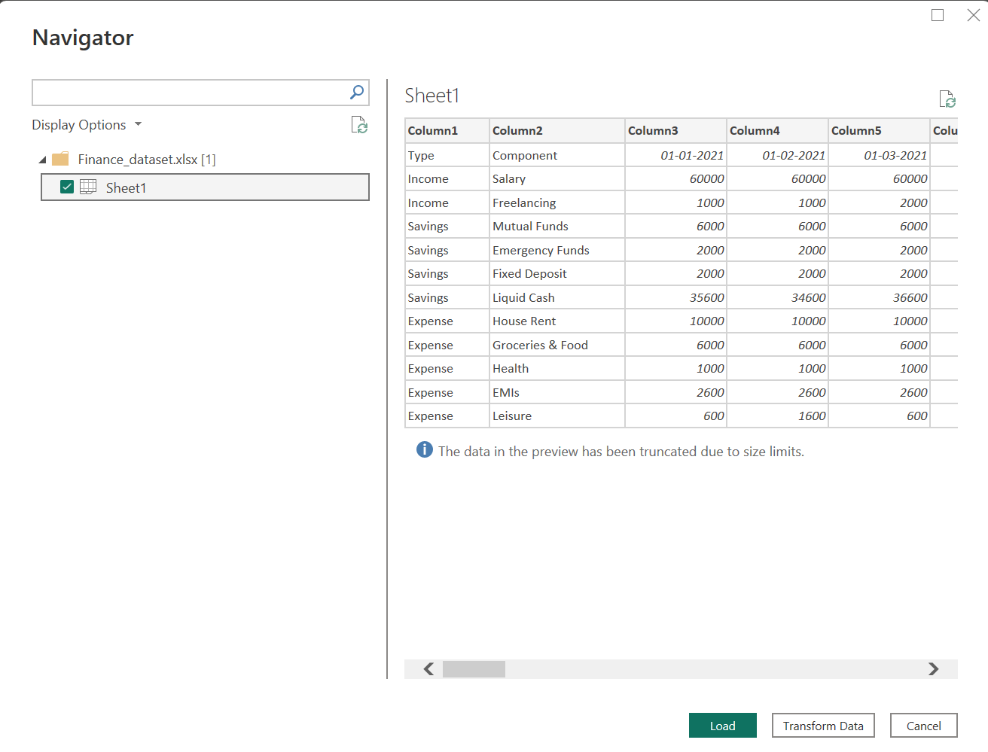

1. After the dataset gets loaded it will be reflected on the right side of the window.

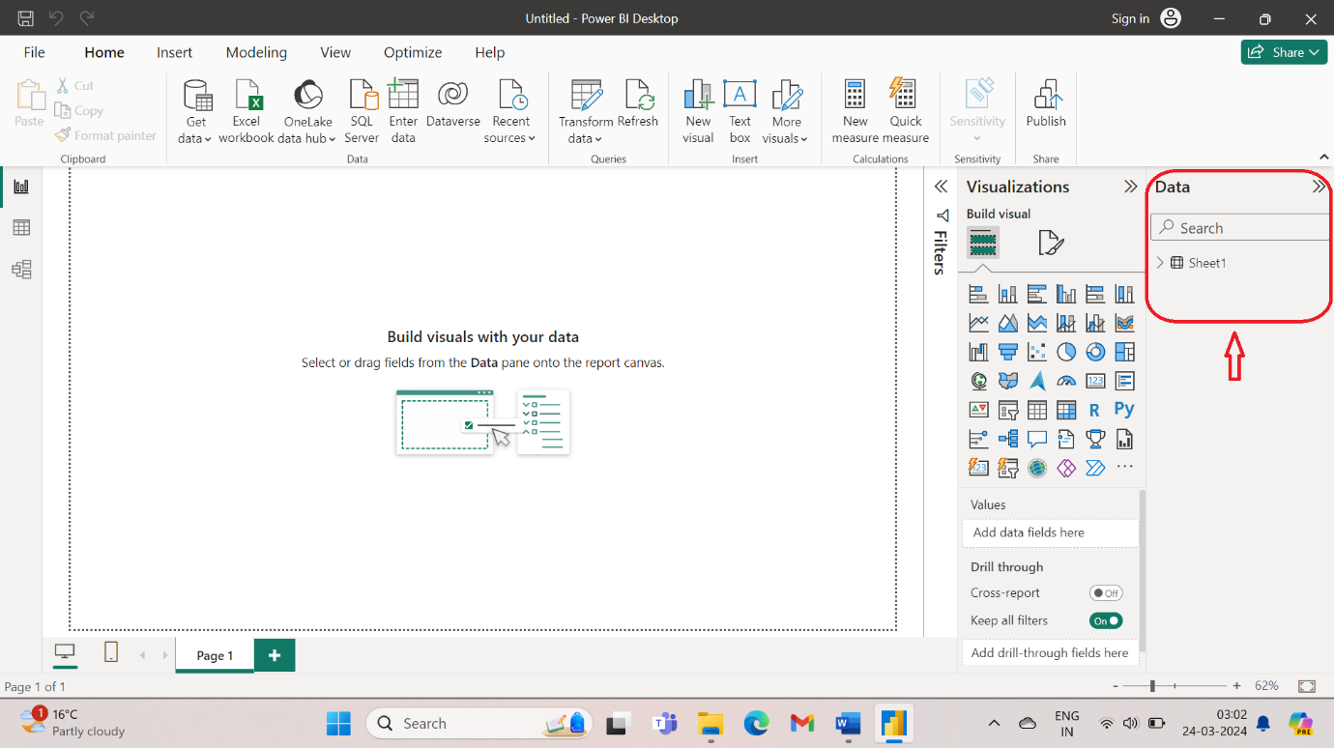

1. Now click on Transform data to open the excel file in Power Query.

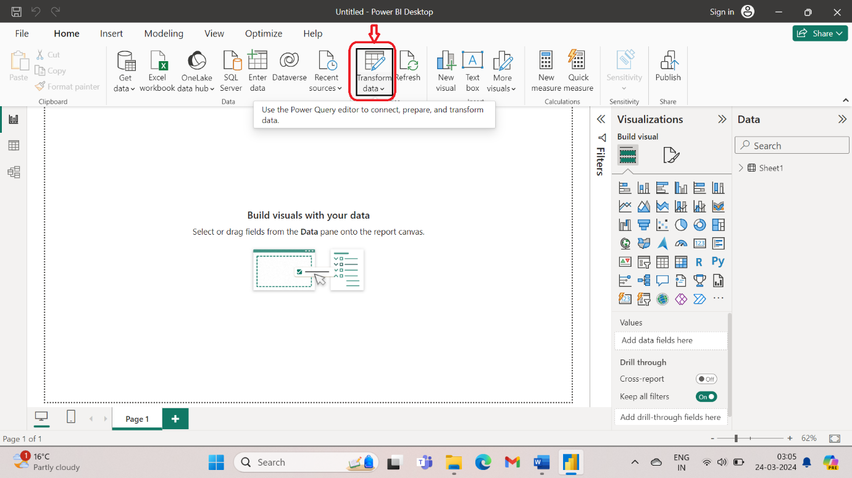

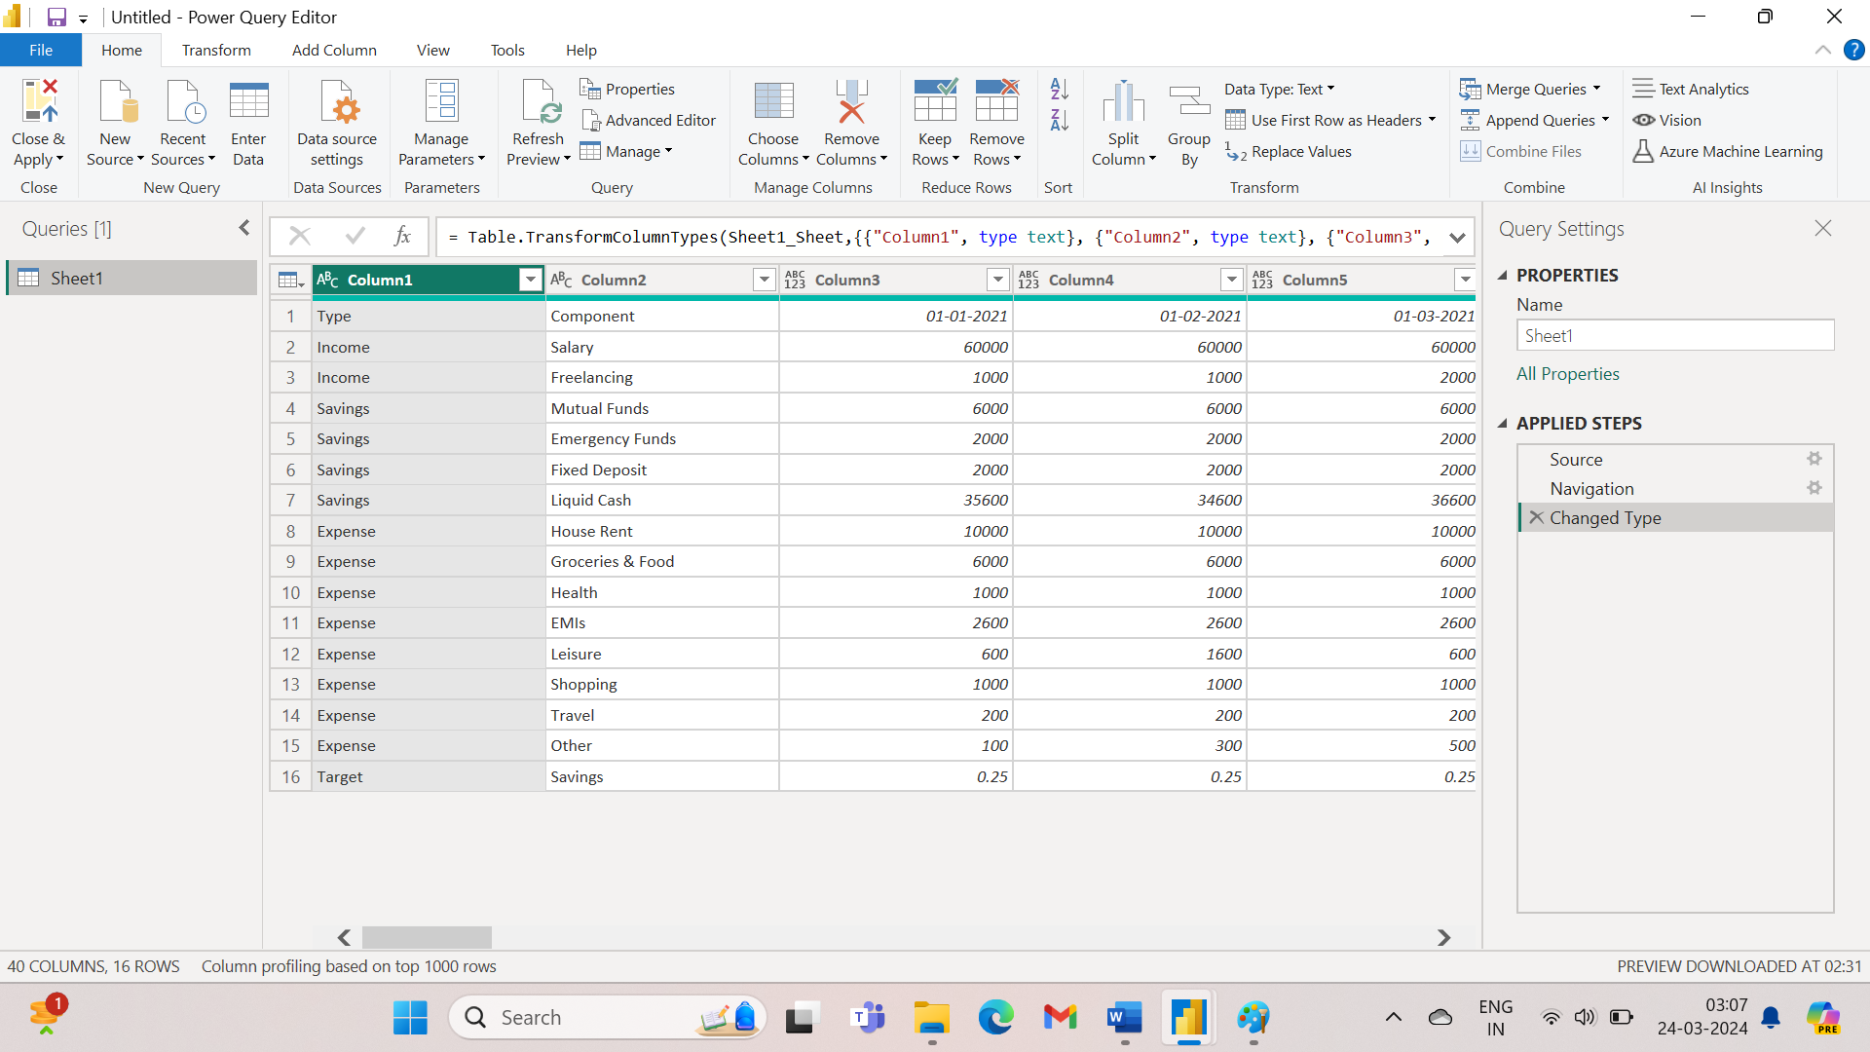

1. Click on Rename tab to rename the file.

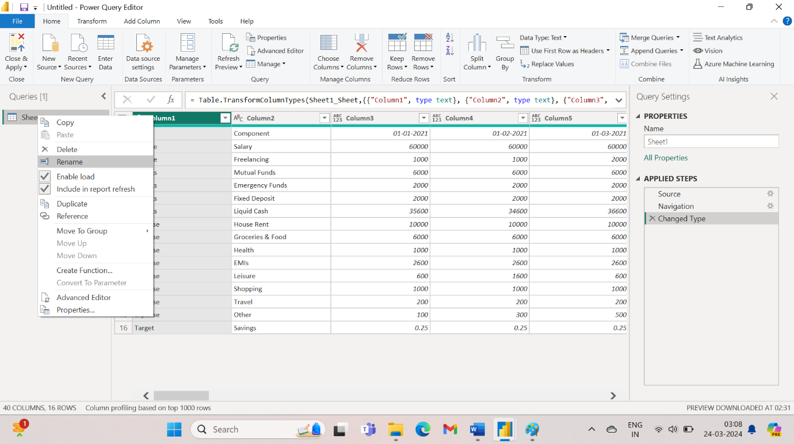

1. Rename the columns and then remove the top row.

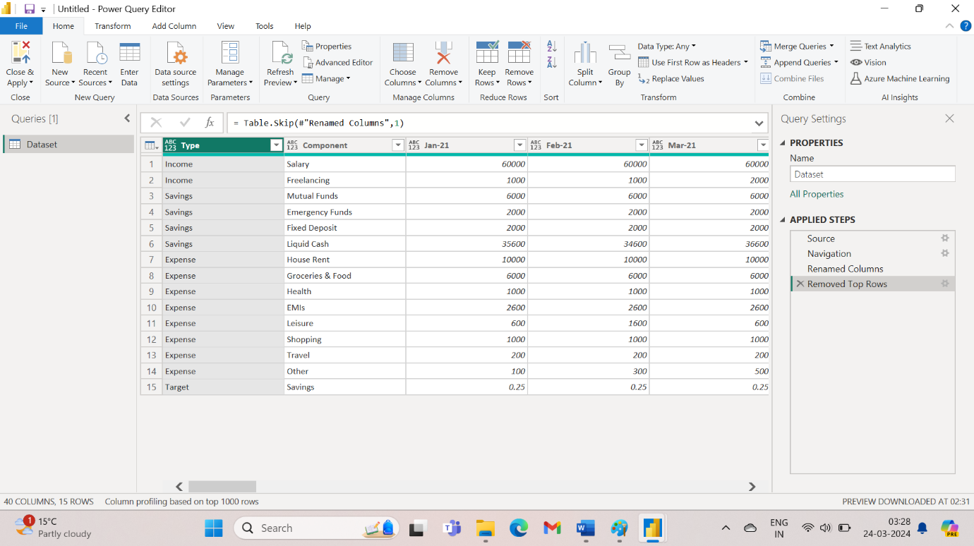

1. The months are coming column wise. If I want that they should come row wise then it will be easy for me. For this Select Columns 3 to 40; right click on the green tab and then click on unpivot columns. This will merge all the columns.

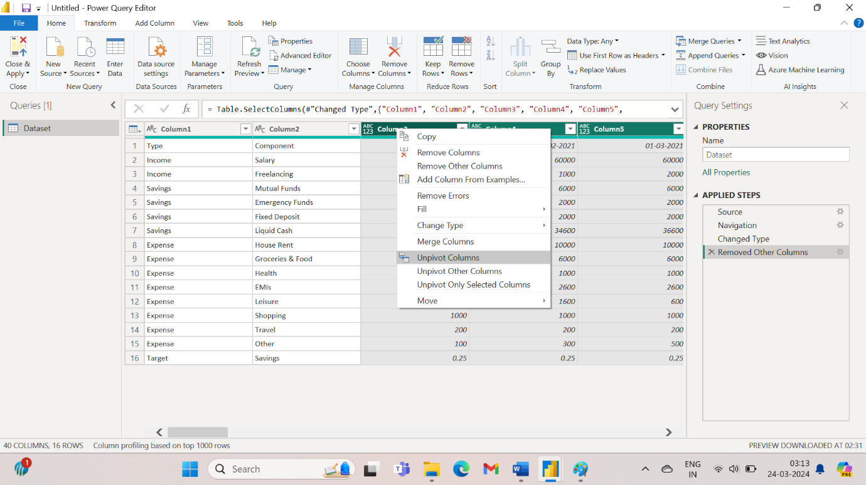

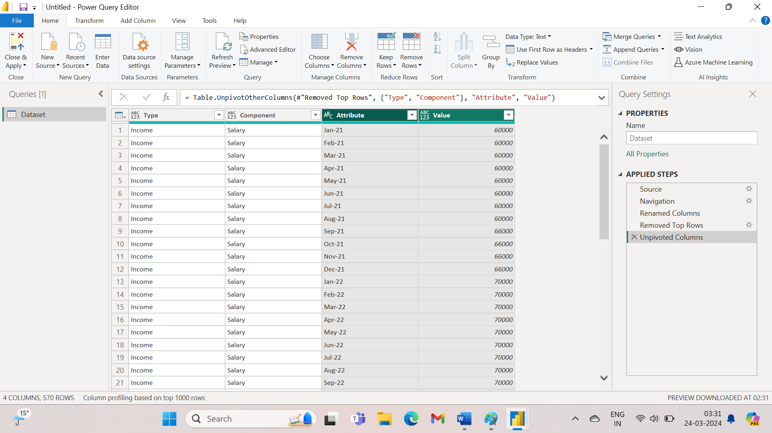

1. Rename “Attribute” column to “Date” and then change its type.

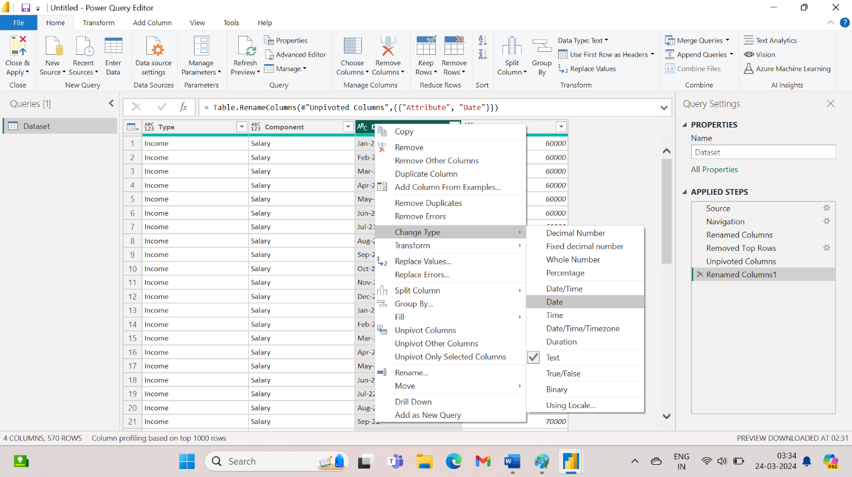

1. Select close and apply from top left-hand corner.
2. Click on dataset > New measure. Then type the name of the column as shown:

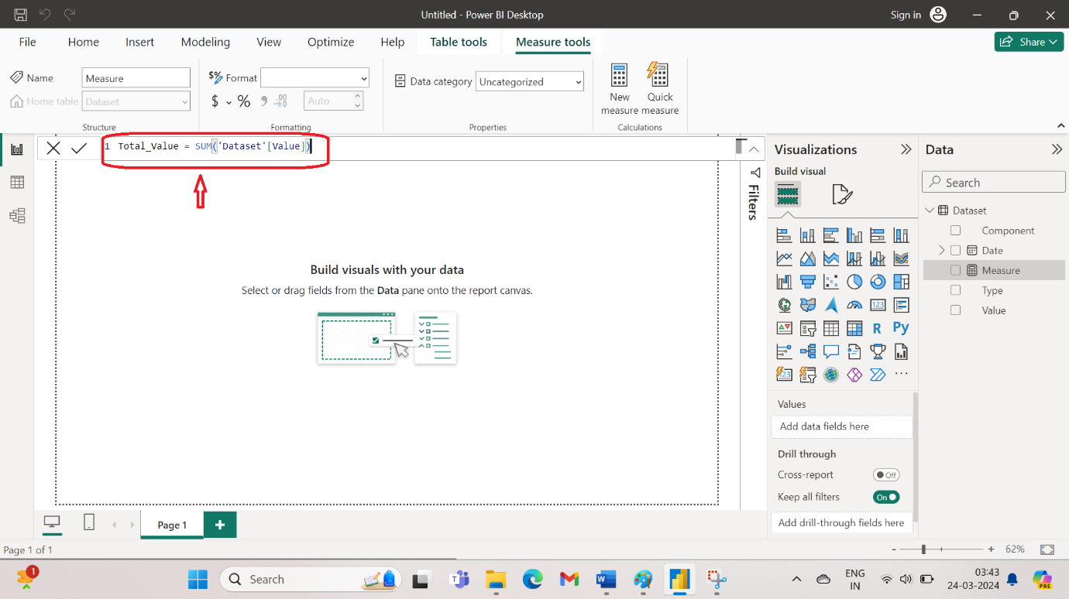

1. To change the currency, click on “$” sign and navigate to Indian rupee.

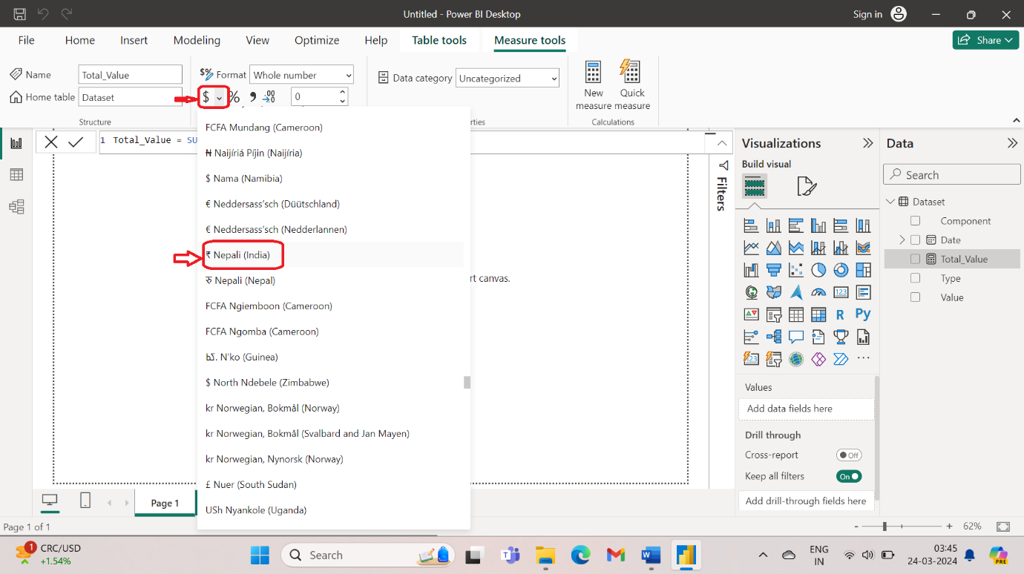

1. Click on Total_Value, drag it to filter by tab. This will generate the visual as shown.

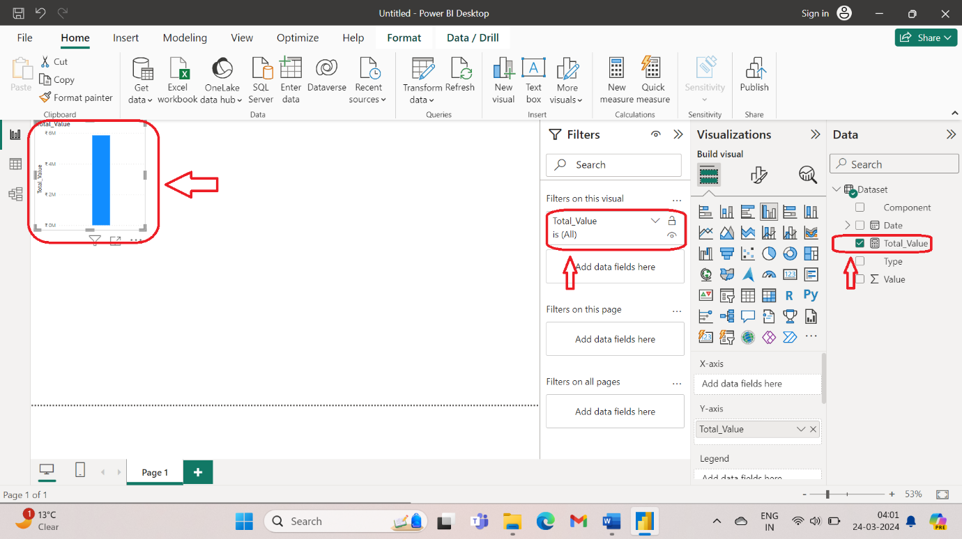

1. Select card 123 and this will display the value as 6M.

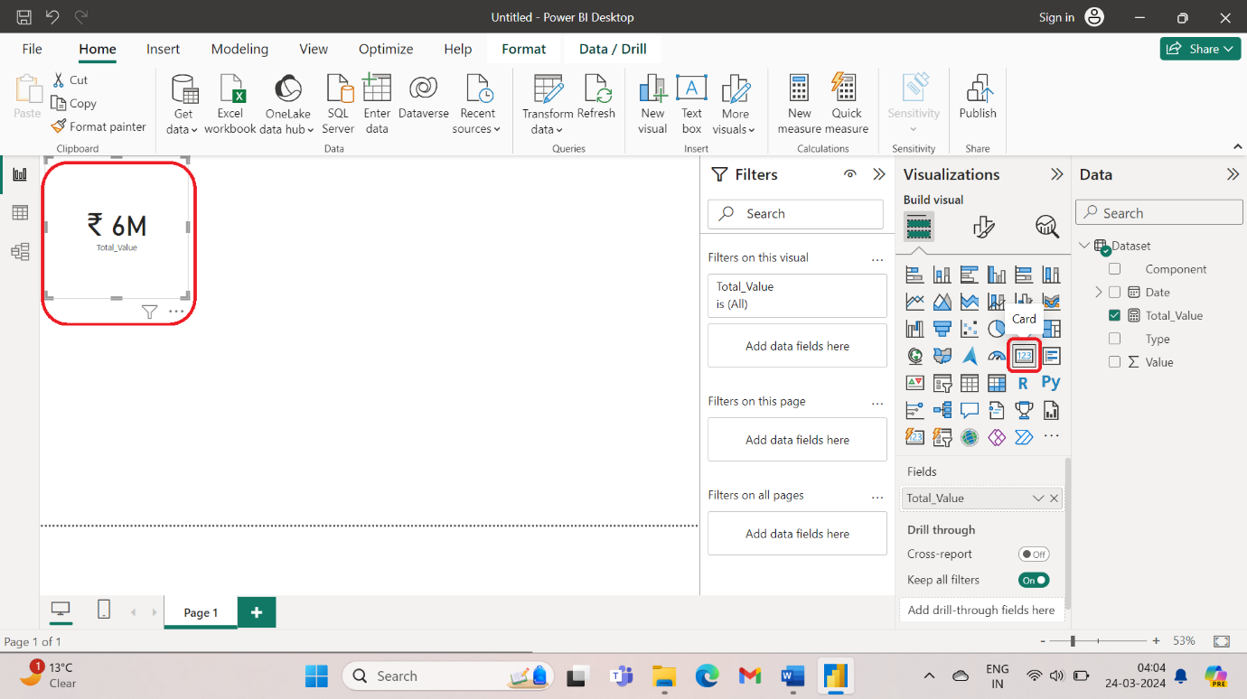

1. Now to represent the income click on Type > Drag to Filter panel> select from a field of basic filtering. This will give value as 3M.

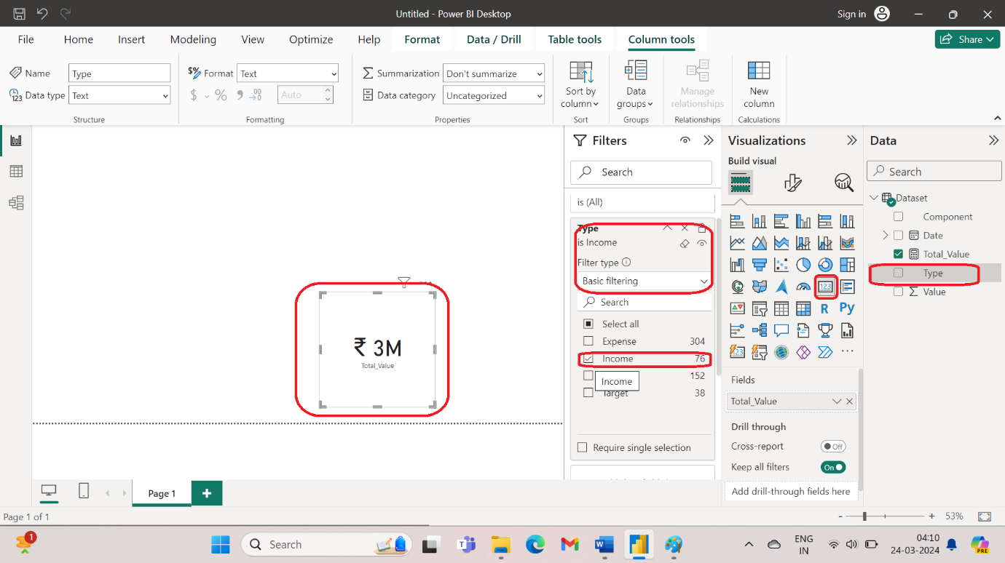

1. The above step can also be done by DAX. Click on Dataset > New Measure > Rename to Income > Type the command as shown to filter on income.

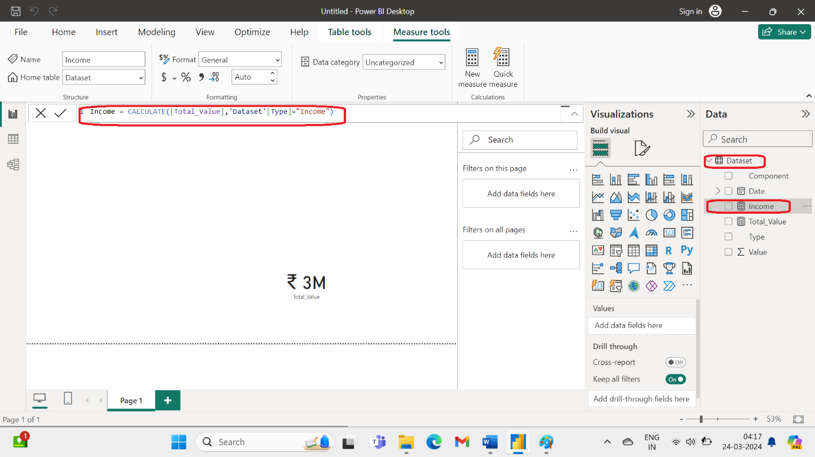

1. Similarly, create expense.

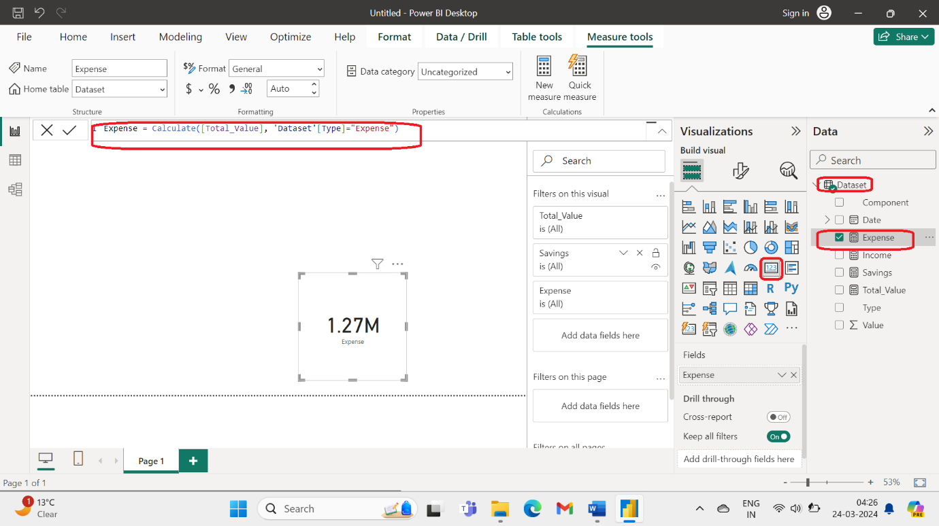

1. Now to display the 3 categories we have made, drag the income to fields. Selest chart. This will show the income as shown in 3.

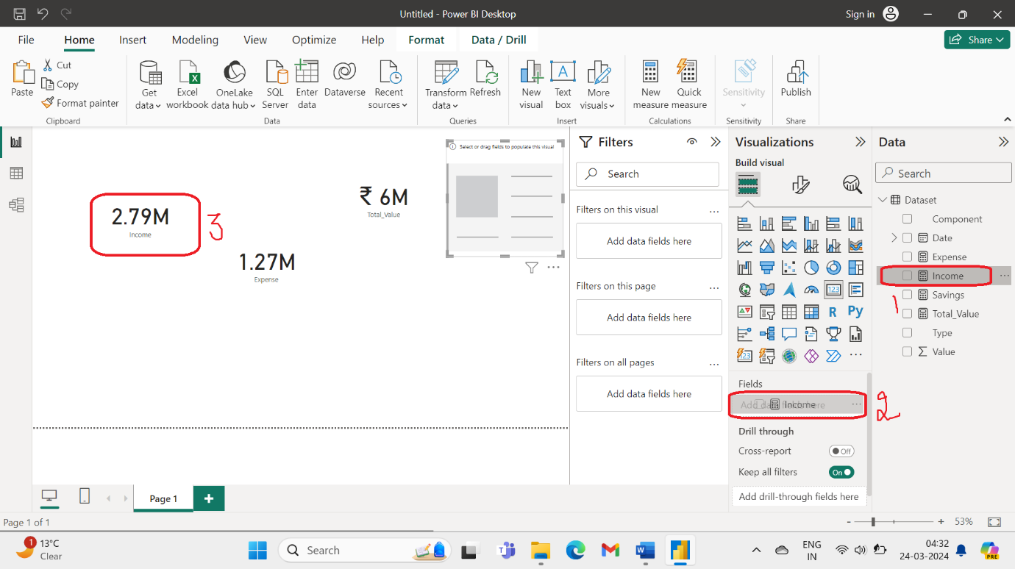

1. Create a new measure Savings%

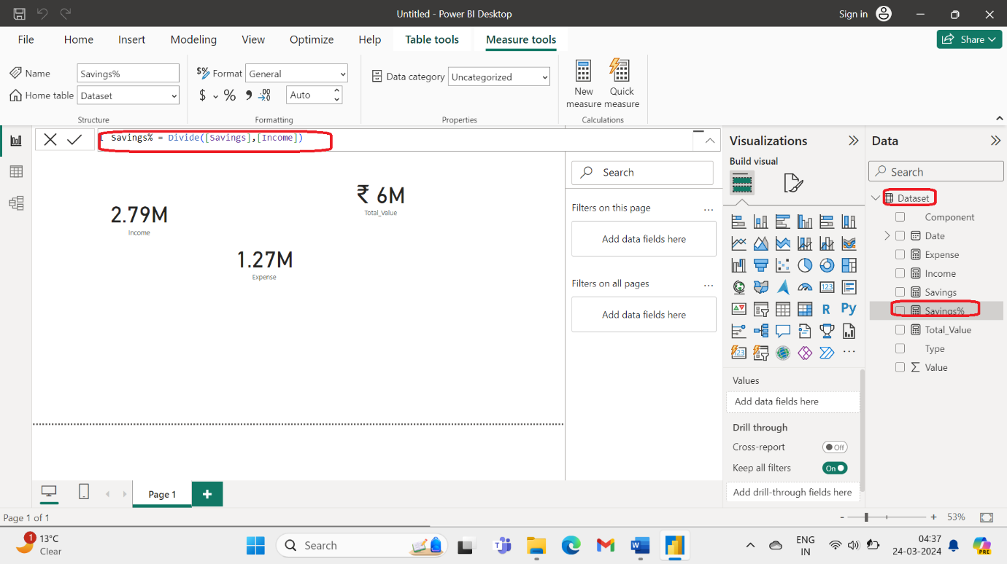

1. To change this into percentage click on savings%. This will open a tab format on top. Navigate to Percentage. This will open be depicted as 63.88%.

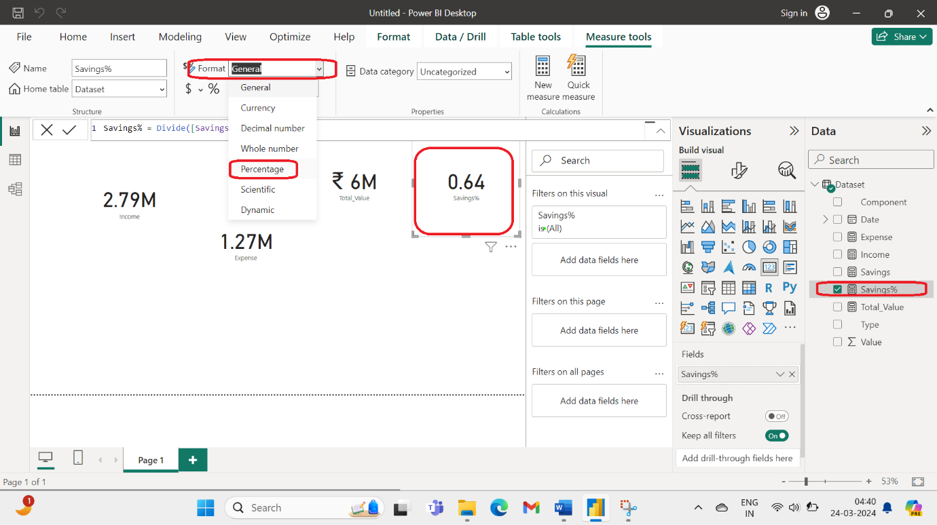

1. Now we have four values – income, expense, total_value and savings%.

To filter the values by year, we need to create a new column. This can be done as follows. Click on new Table view, Home, New column. Then type the value that you need. This will change the column name to year and populate it with the year.

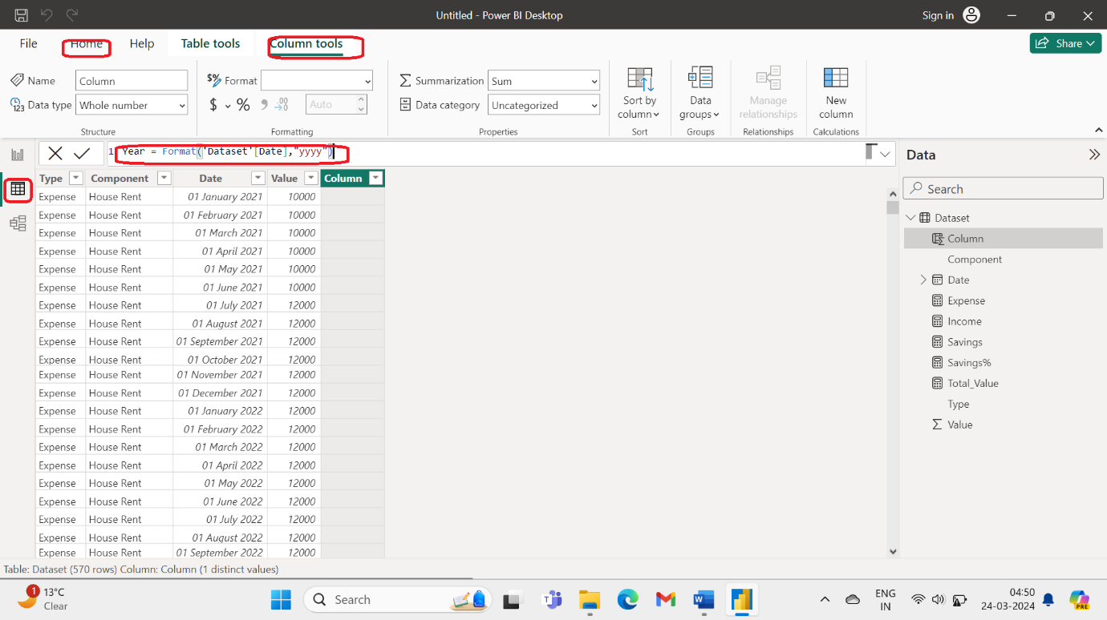

1. Similarly create month-yr column.

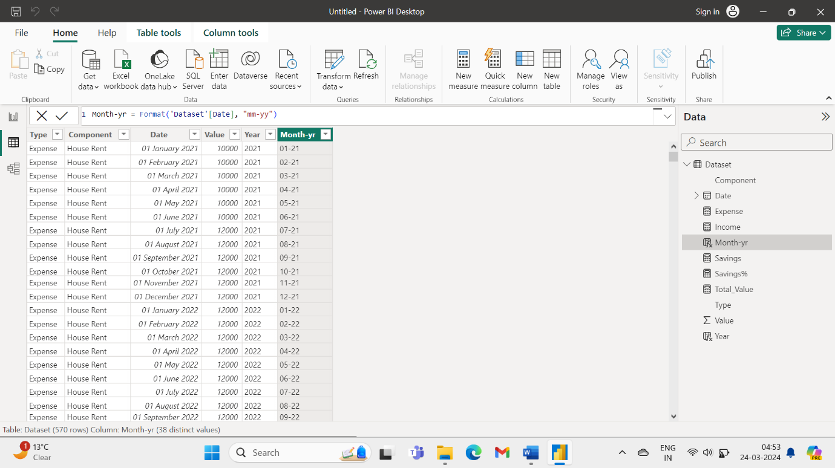

Click on format your visual. Select slicer settings. Select All. This will add select all feature.

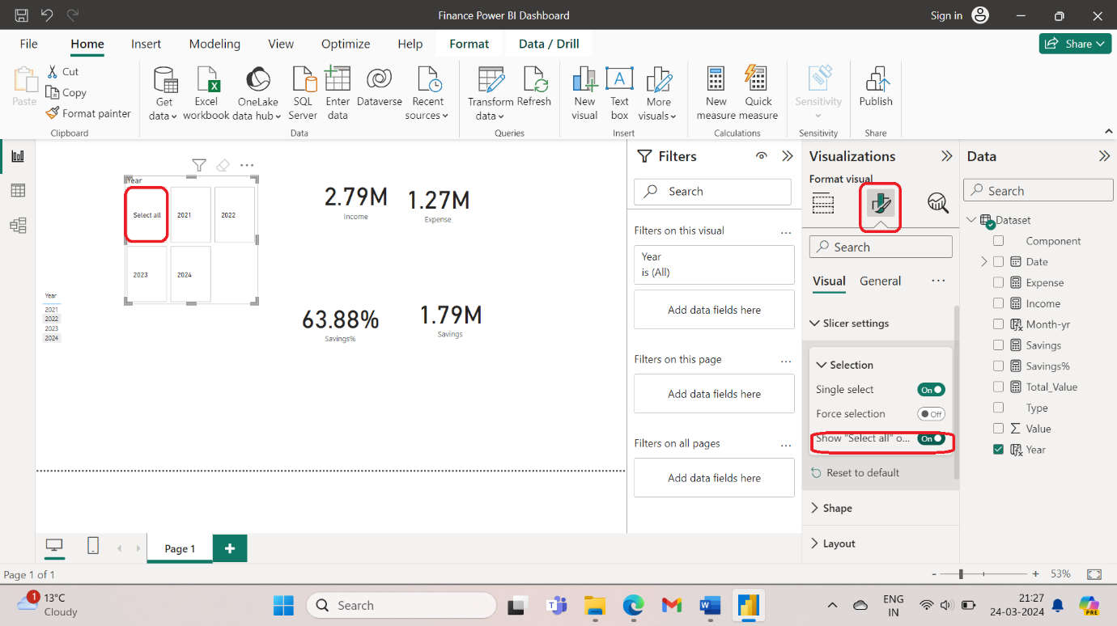

1. In format your visual, select layout and then select the number of rows and columns that is needed. This will generate a slicer as shown.

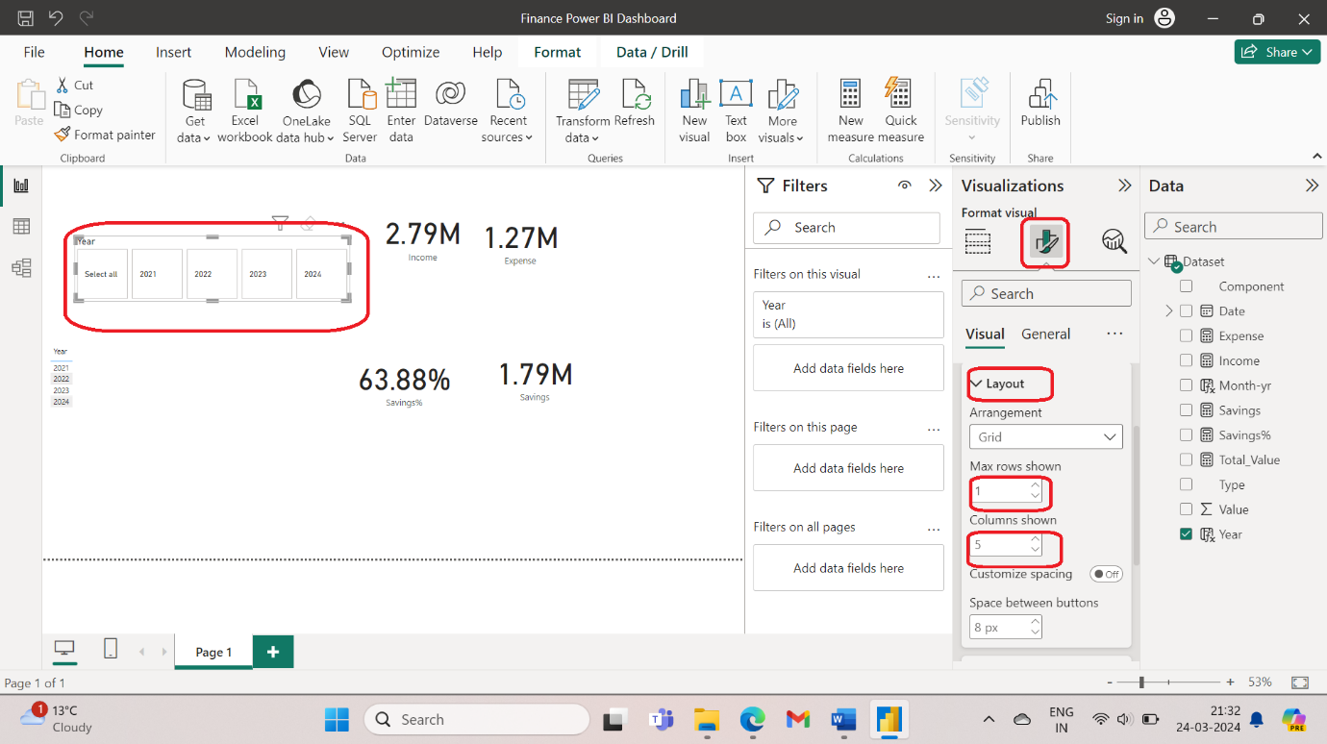

1. In Format visuals, select callout values > centre alignment. This will align the value sin the centre.

From shapes select rounded rectangle.

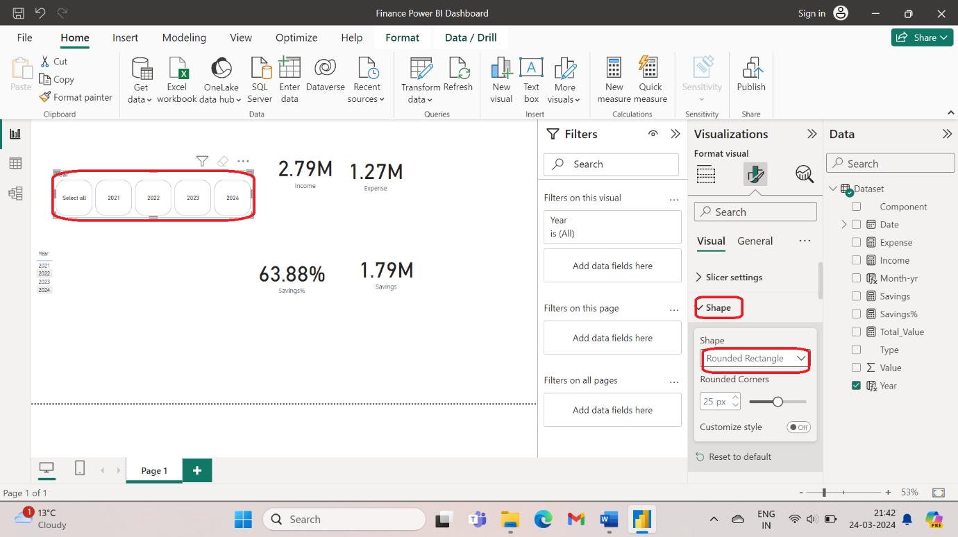

1. To change Font, select values > Segoe UI semibold.

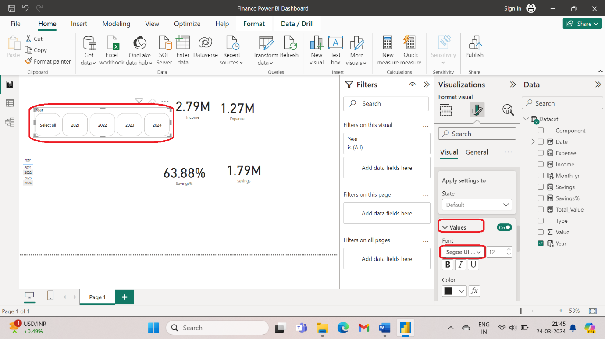

1. Go to Buttons > Apply Settings to > State > Default > Fill > Color > Light gray

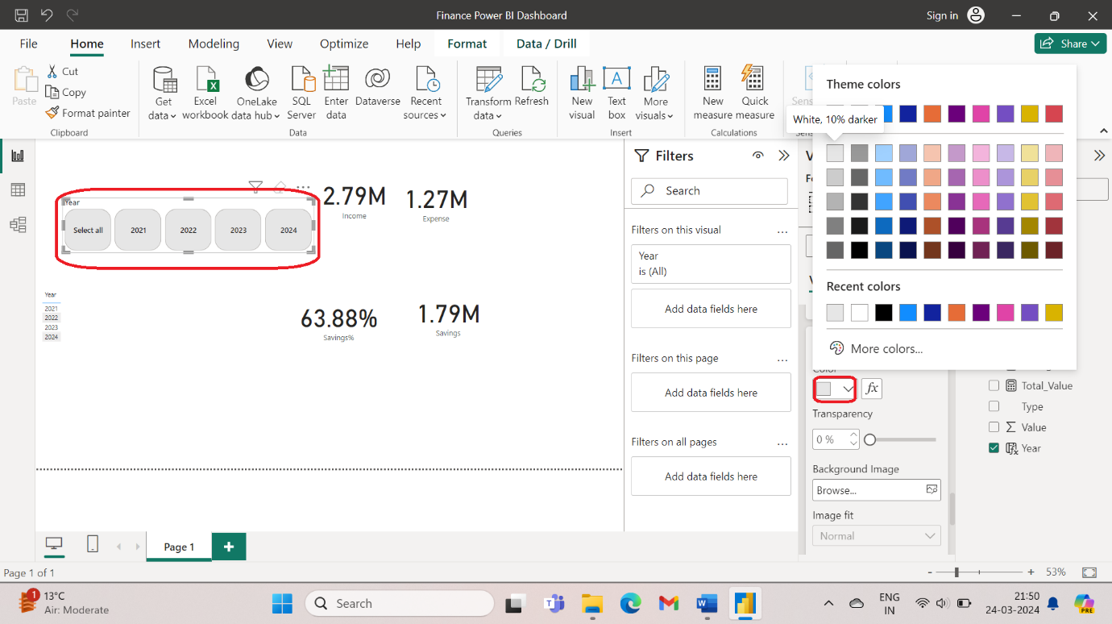

1. Select Buttons > Borders > Off. This will not show the borders.

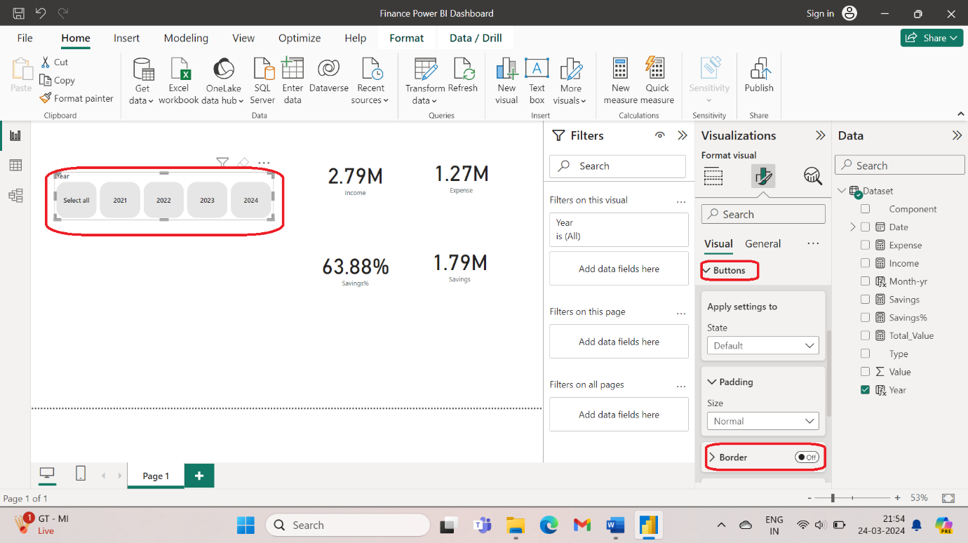

1. Go to Format your Visual > Visual > Buttons > Apply state to Selected > Fill> Purple.

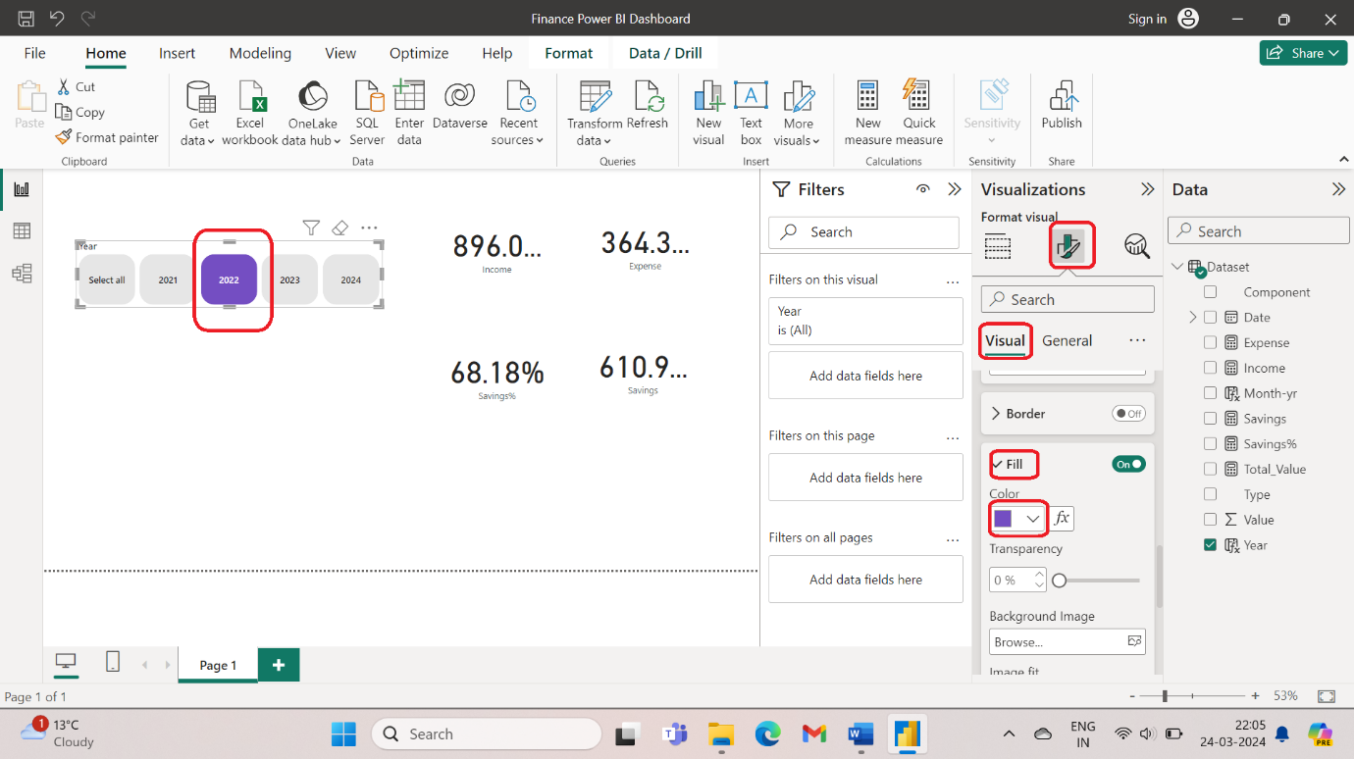

1. Now select Total_value > donut chart > legends --- components. This will break the total values into various components.

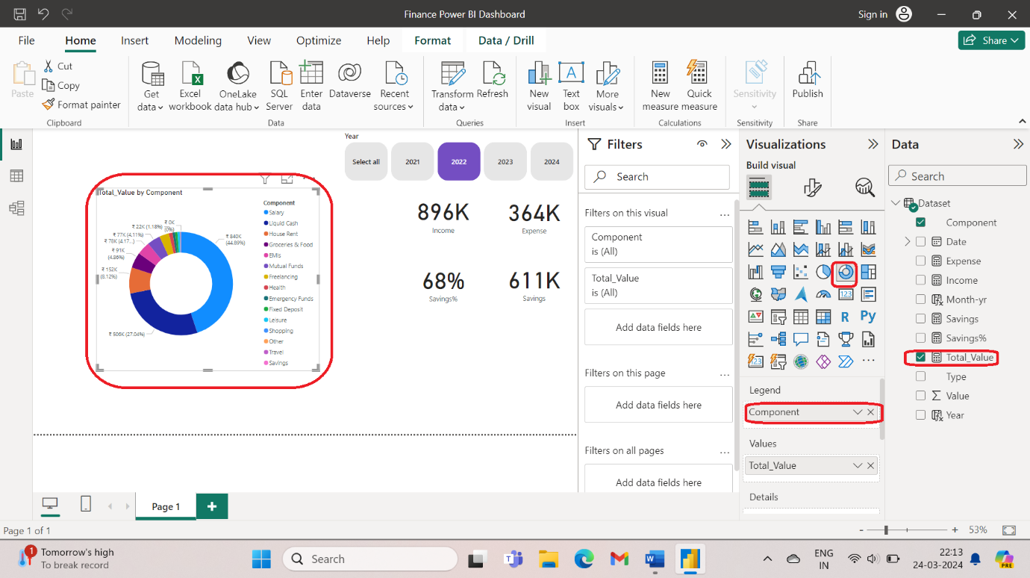

1. If I add savings in values then it will generate the savings dashboard.

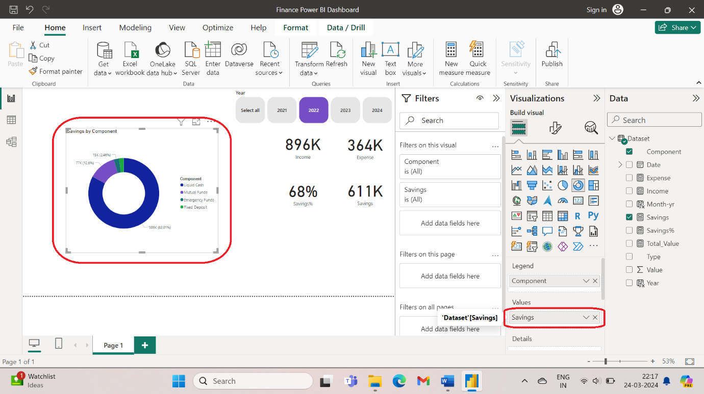

1. Now do ctrl + c and ctrl + v. select expenses. This will give donut chart of expenses.

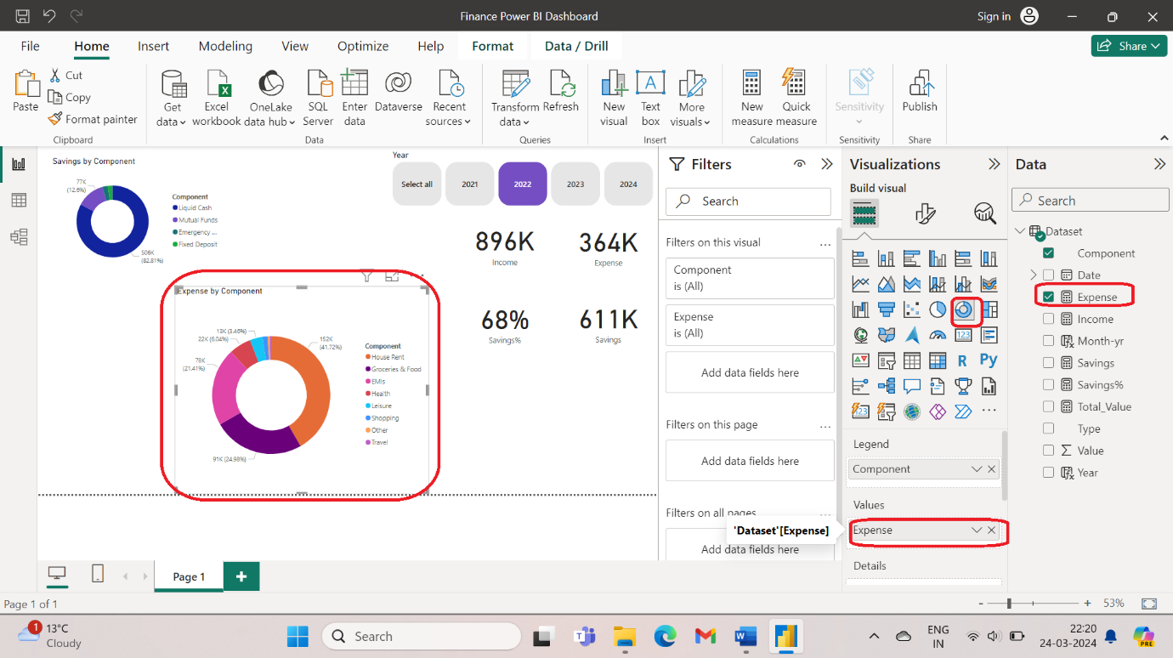

1. To change the title of the charts, go to format visual > general > Title> Text > savings.

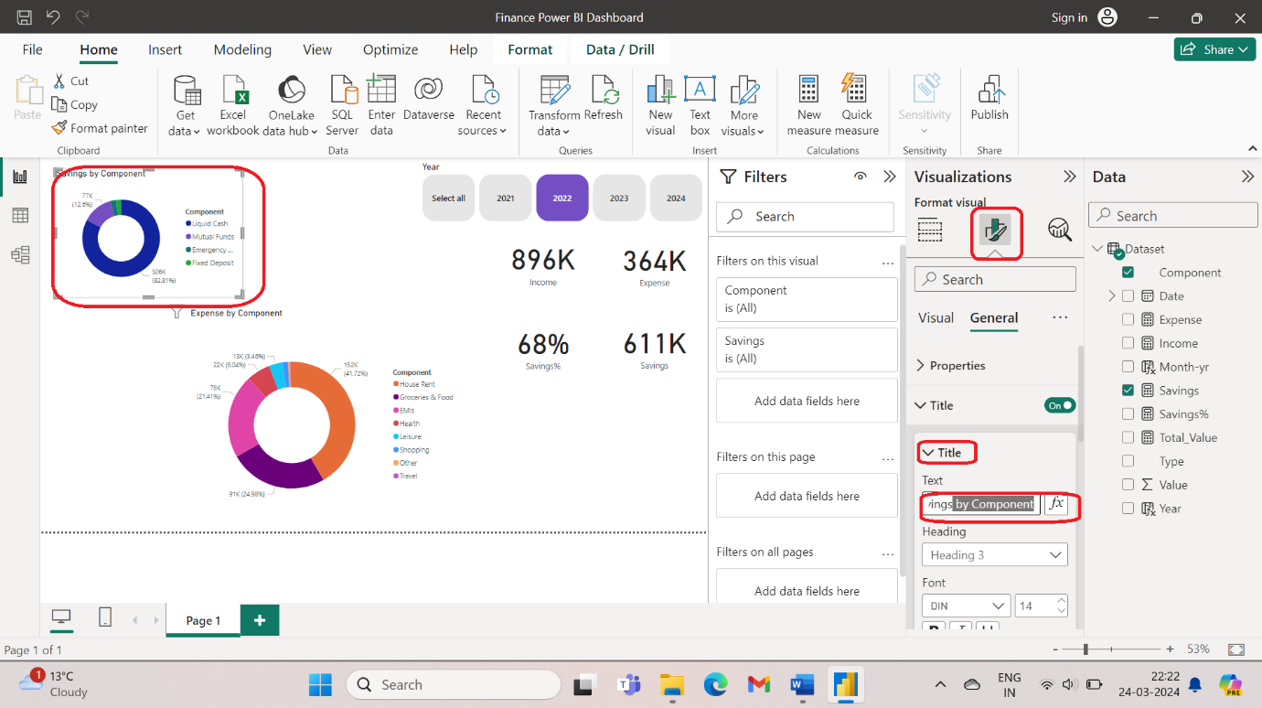

1. To change the font select the font and font size.

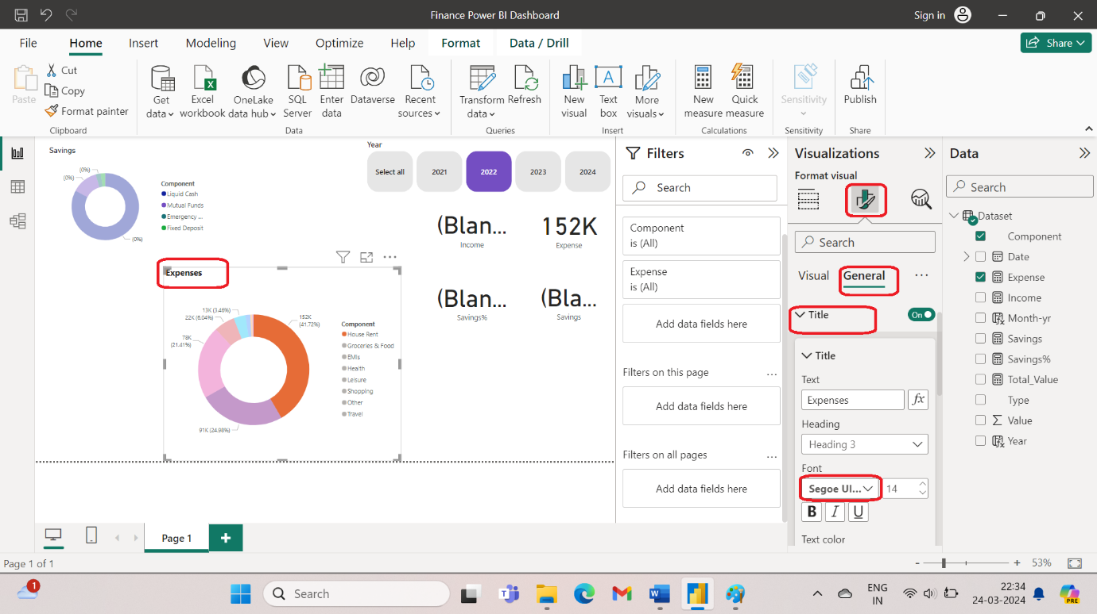

1. Similarly we can do for Expenses.
2. To create a divider between the title and the donut chart:

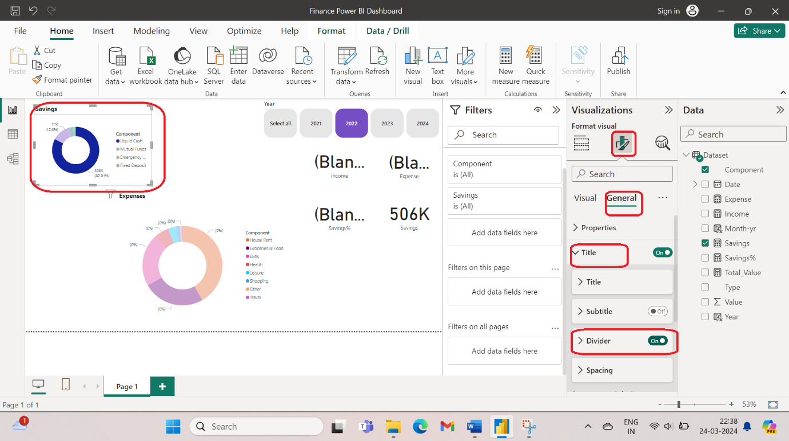

1. Select format visual > General > Visual Border > Color > Gray > 14px. This will give rounded corners to the savings donut chart and match with the theme of my dashboard.

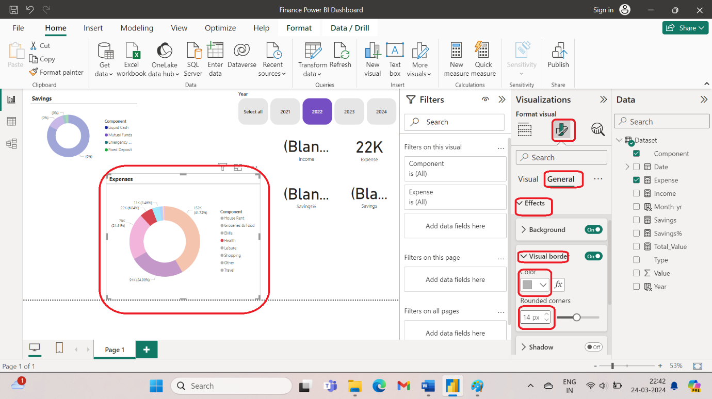

1. To switch off the data labels:

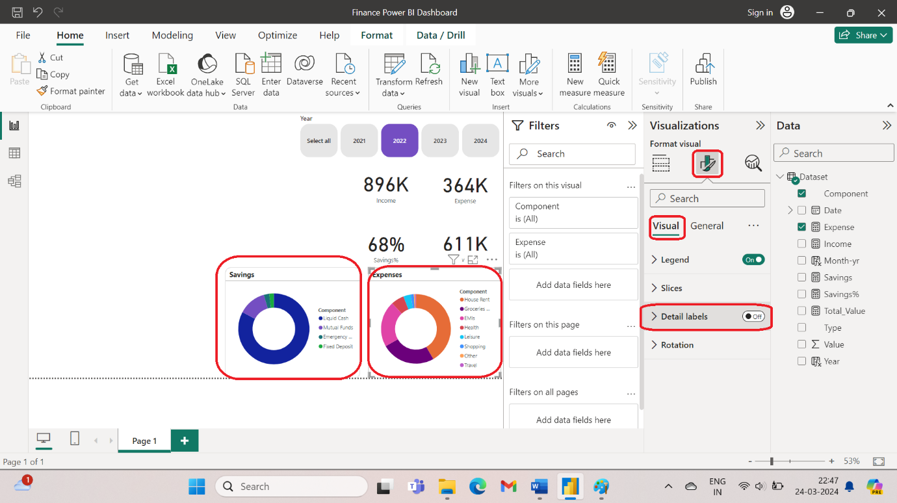

1. If I want to add a table, click total values > matrix > rows > type> components. If I click on any of the types, it will expand all the elements of that component.

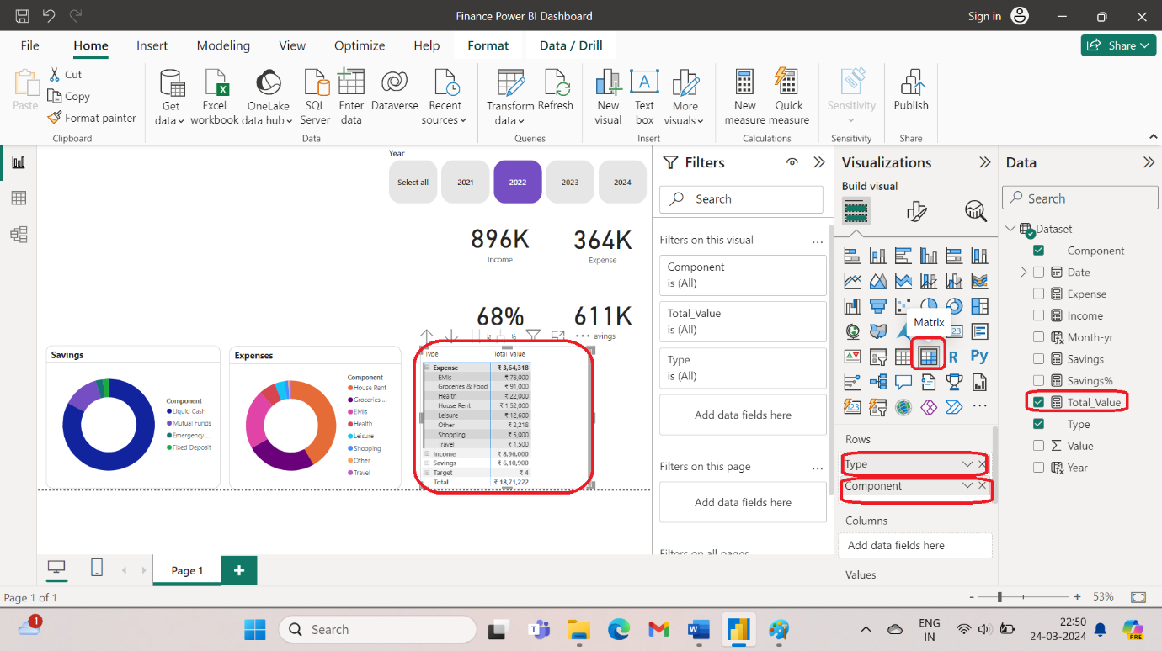

1. To break it year wise, add year to columns.

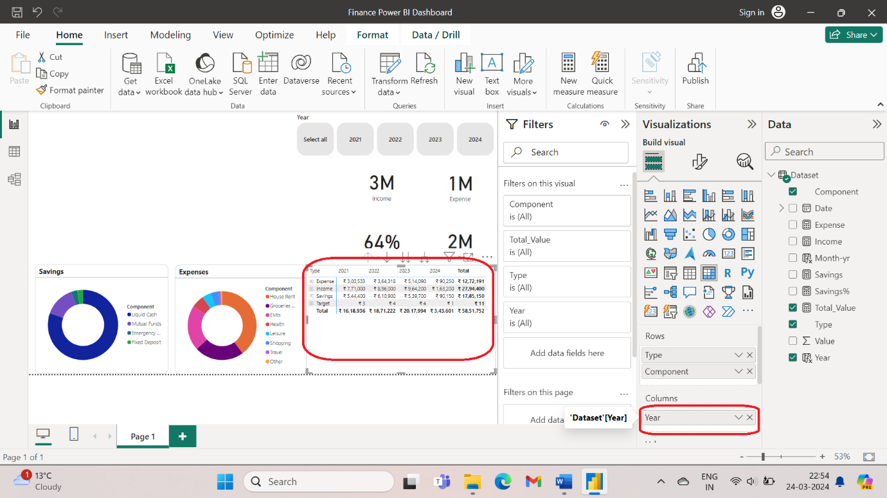

1. To remove borders from a table, go to visual > Grid > Border > select border position, color , width.

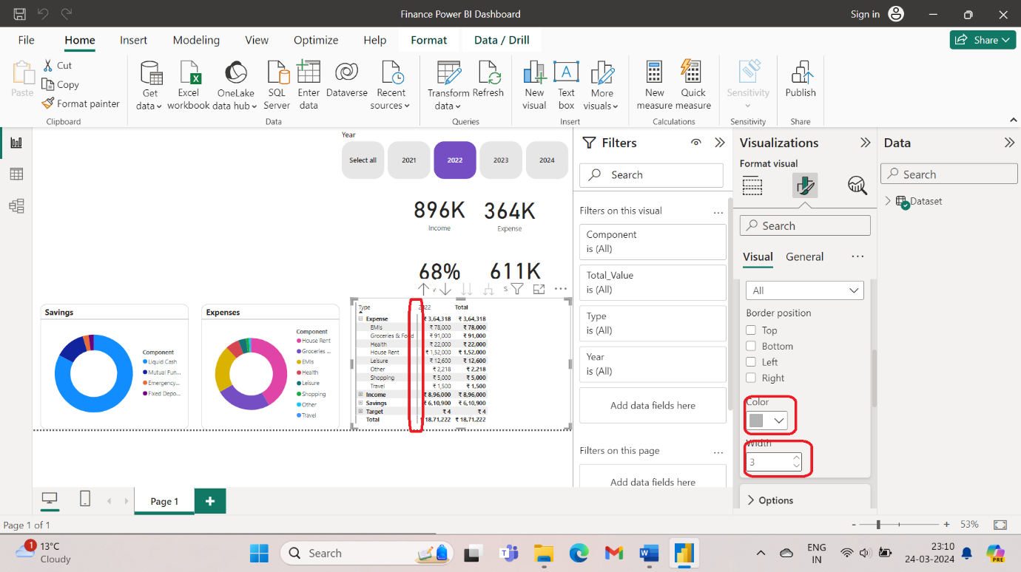

1. Suppose you want to change the colours of the charts. Go to format visuals > visuals > slices > select the colour you want.

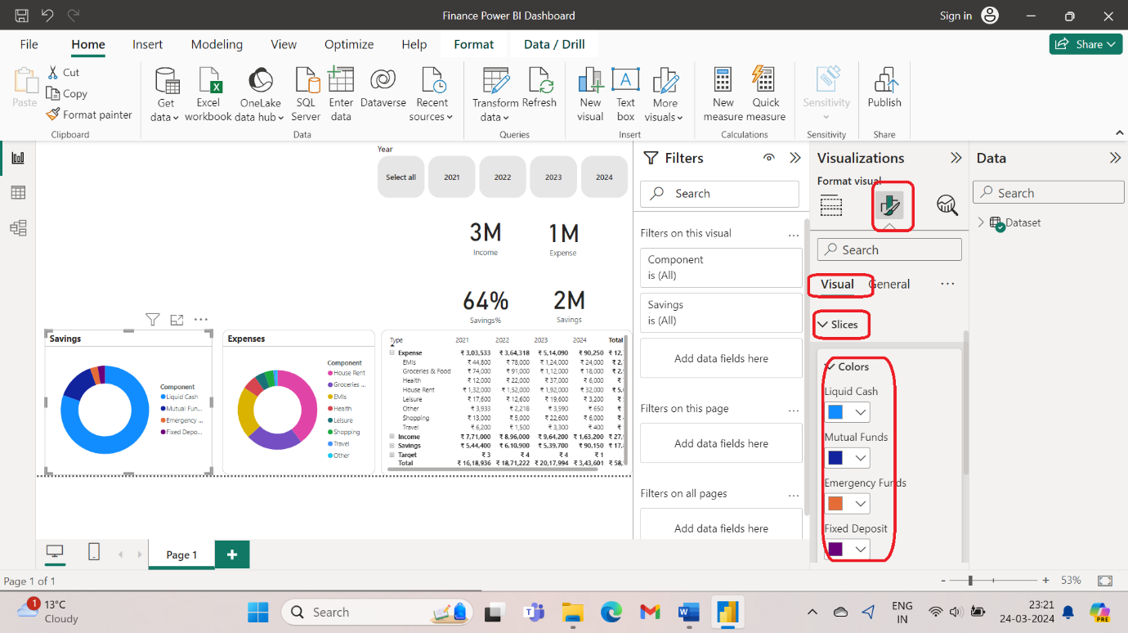

Suppose you want to change the colours all at once, Go to view > Customise themes and then select theme colours.

1. Now I want to plot the income in line chart. To do this do ctrl+c and ctrl+v of the income 3M. Now, select date on x-axis, income, expenses, savings on y-axis. Thi gives an advantage that the custom theme colours are applied to the line chart.

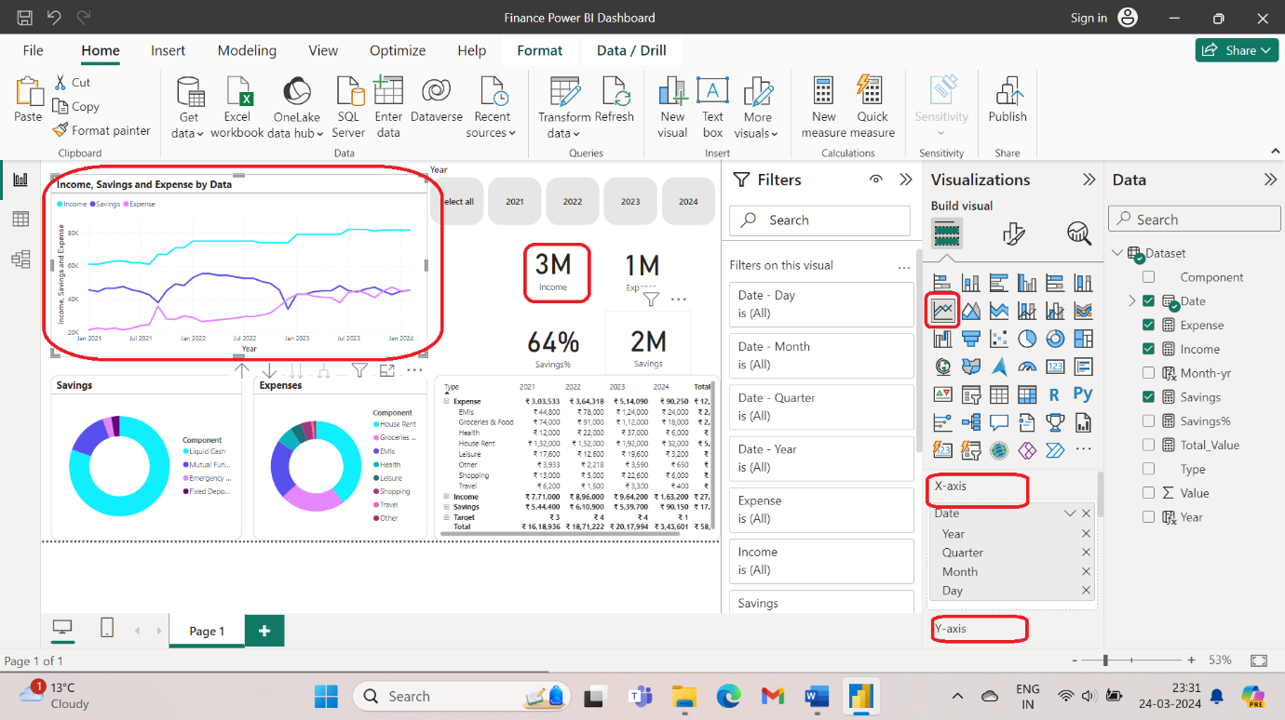

1. Create a new measure

Income LM = CALCULATE([Income],DATEADD('Dataset'[Date],-1,Month))

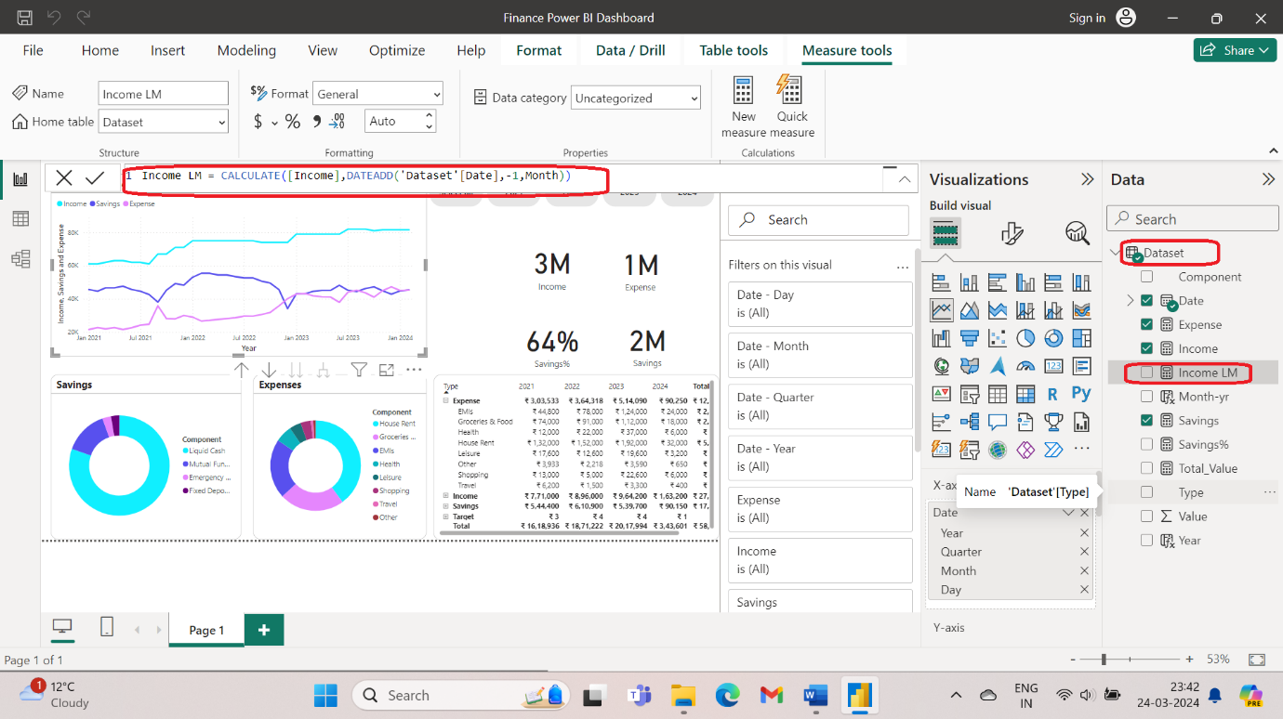

1. Create another measure:

Expense % = Divide([Expense],[Income])

1. In this way, you can create more measures and visualize using bar chart.